**LAB 05**

**MULTIPLE LINEAR REGRESSION**

**Aim: To perform Multiple Linear Regression on a Dataset**

**New-Term used:**

1. **lm(): This function is used to perform linear regression analysis. It is used to fit a multiple linear regression model with Y as the dependent variable and X1 and X2 as the independent variables in the first example, and with weight as the dependent variable and gear and hp as the independent variables in the second example.**
2. **scatterplot3d(): This function is from the "scatterplot3d" package and is used to create 3D scatter plots. It is used to create a 3D scatter plot of Y, X1, and X2 in the first example and weight, gear, and hp in the second example.**
3. **graph$plane3d(): This function is from the "scatterplot3d" package and is used to add a plane representing the regression model to a 3D scatter plot. It is used to add the regression plane based on CarModel to the 3D scatter plot in the second example.**

**Input:**

**#Multiple Linear Regression**

**#Applying multiple linear regression model**

**#computing and interpreting the multiple**

**#determination**

**#input the bariables**

**Y=c(110,80,70,120,150,90,70,120);**

**Y**

**X1 = c(30,40,20,50,60,40,20,60);**

**X1**

**X2= c(11,10,7,15,19,12,8,14);**

**X2**

**#Linear regression model of Y on X1 & X2**

**#Here Y is dependent variable and other are independent**

**RegModel = lm(Y~X1+X2);**

**RegModel**

**#Summary of the data**

**summary(RegModel)**

**#From the summary we know that the line equation of the regression is**

**#Y = -0.2442X1 + 7.8488X2 + 16.8314**

**#multiple LR in 3 variables represents a plane equation**

**#install package scatterplot3d or type**

**#install.packages("scatterplot3d");**

**library(scatterplot3d);**

**#plot the data set**

**scatterplot3d(Y,X1,X2);**

**#Problem 2**

**data = mtcars**

**data**

**weight = data$wt;**

**gear = data$gear;**

**hp = data$hp**

**CarModel = lm(weight ~ gear + hp)**

**summary(CarModel);**

**graph = scatterplot3d(weight,gear,hp,color="red",bg="yellow")**

**graph$plane3d(CarModel);**

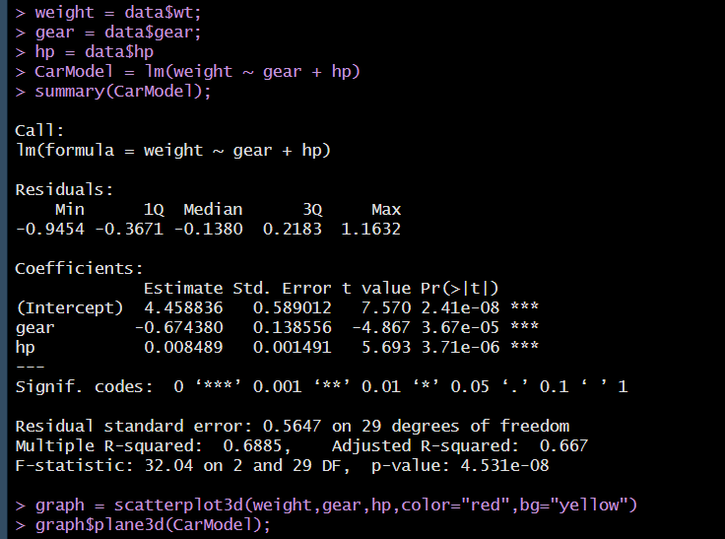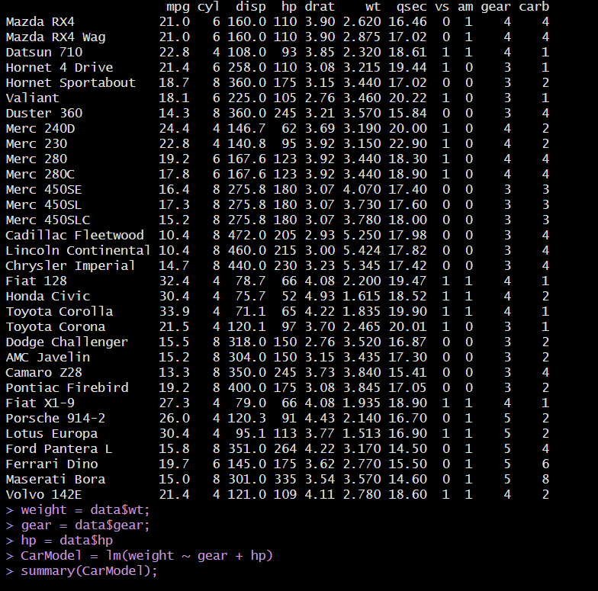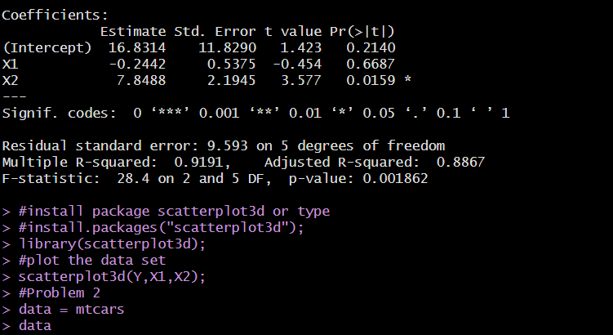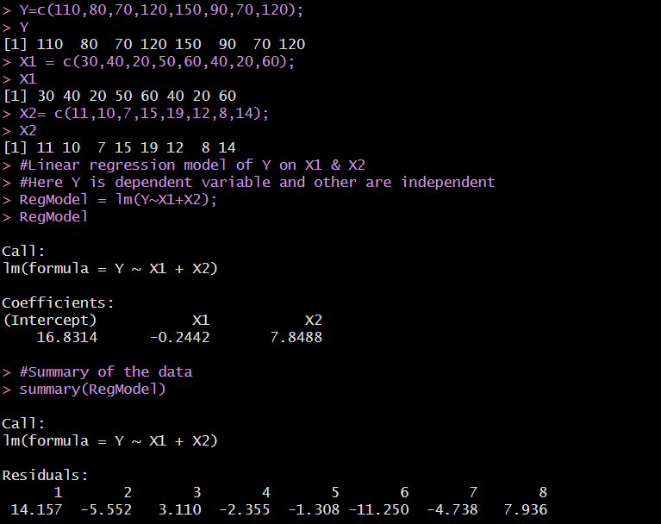**OUTPUT:**

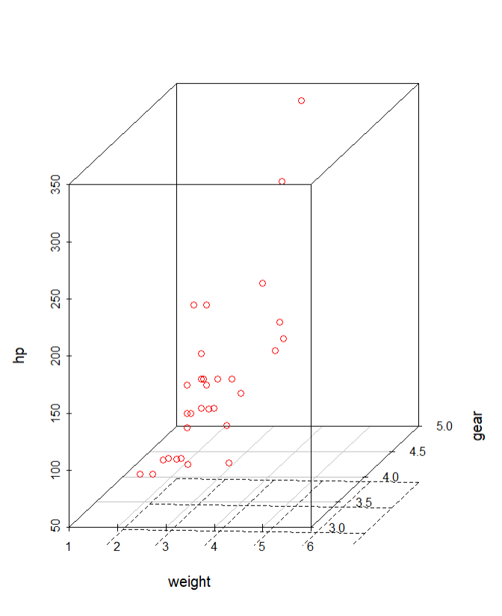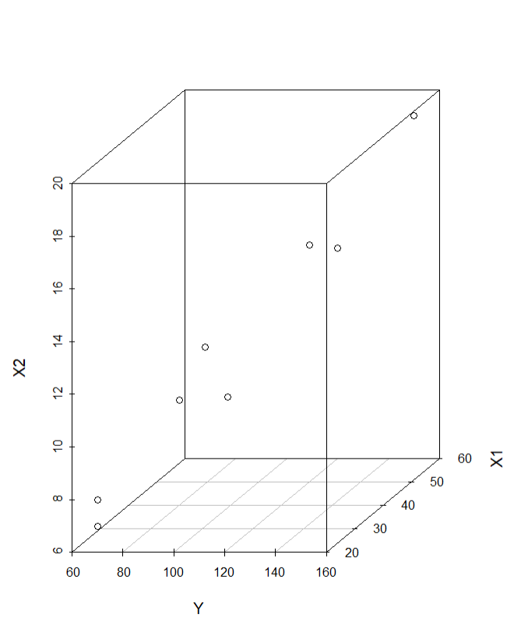

**Inference:**

**Hence Multi-linear Regression is calculated and visualized in R programming**

**\*\*\*\*\*\*\*\*\*\*\*\*\*\*\*\*\*\*\*\*\*\*\*\*\*\*\*\***